**Test Automation – Assignment IV**

**Application to be tested - URL:**

https://www.amazon.in

**Instructions:**

* Use different locators
* Include Assert statements
* If any of the steps is missing for the test scenario, you can pick alternate step/scenario from the same website and proceed with the automation
* Use Chrome Browser
* Include Time delays ( sleep/implicit/explicit) wherever needed

**Tasks:**

* Go to amazon.in

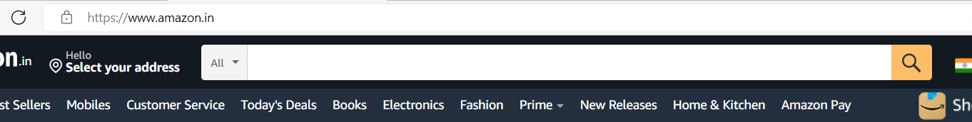c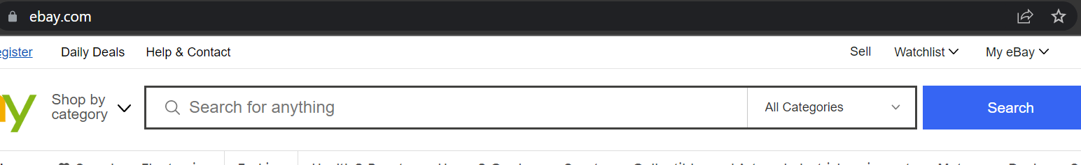

* Enter “bluetooth headphones” in searchbox and select “electronics” from the categories dropdown

c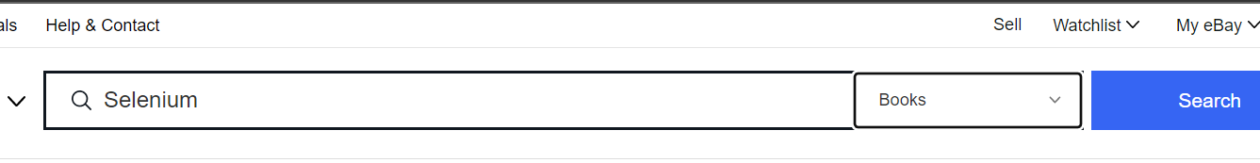

* Click Search button
* Select “Newest arrivals”



Validate if the item displayed at the top has current date with “Sep” in it.



Select get it by today



**Refer screenshot for each step**